Assessment 1:
Financial Analysis Dataset: https://github.com/Priya-tops/Tops-Assessment-Data/blob/main/Data%20Analytics/financ e_economics_dataset.csv
Explore the Data by Answering the Following Questions and Summarize Your Insights Use Python libraries such as Pandas, NumPy, Matplotlib, and Seaborn to analyze the data. After answering each question, write a brief summary of your findings or observations.
- What is the shape of the dataset?
Ans:
df.shape

output:
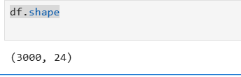

- What are the column names and their data types?
Ans:
df.dtypes

output:
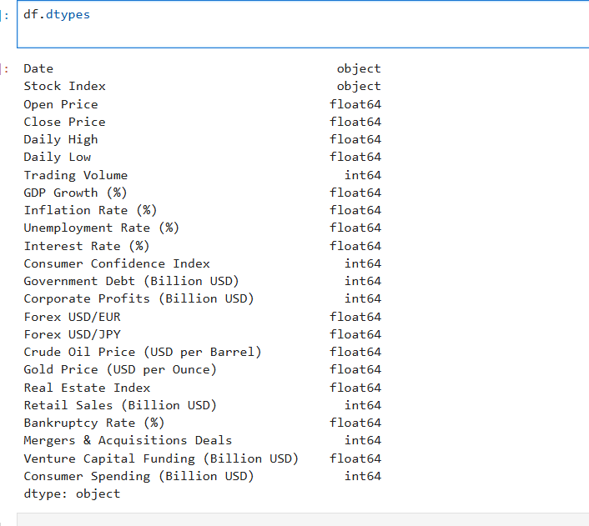
- How many unique stock indices are there?
Ans:
df["Stock Index"].nunique()

output:
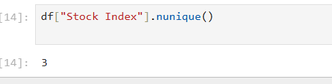
- What is the date range of the dataset?
Ans:

df["Date"] = pd.to_datetime(df["Date"])
df["Date"].min(), df["Date"].max()

output:
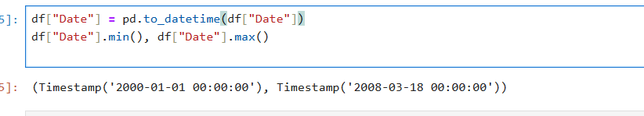

- Are there any missing values?

Ans:

df.isnull().sum()

output:
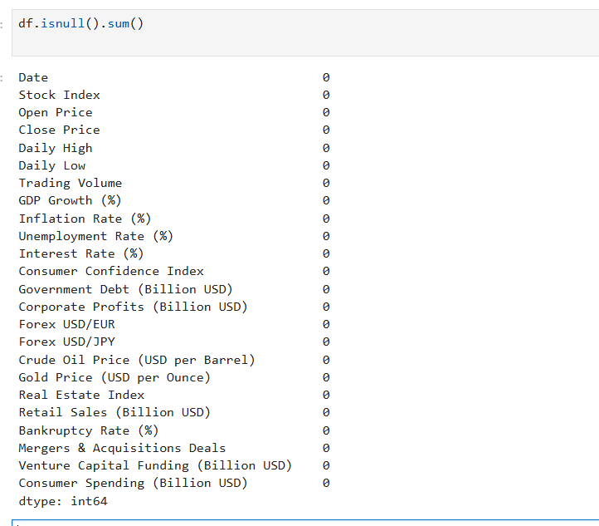
- Are there negative values in columns that should be non-negative?
Ans:

(df.select_dtypes(include="number") < 0).sum()

Output:
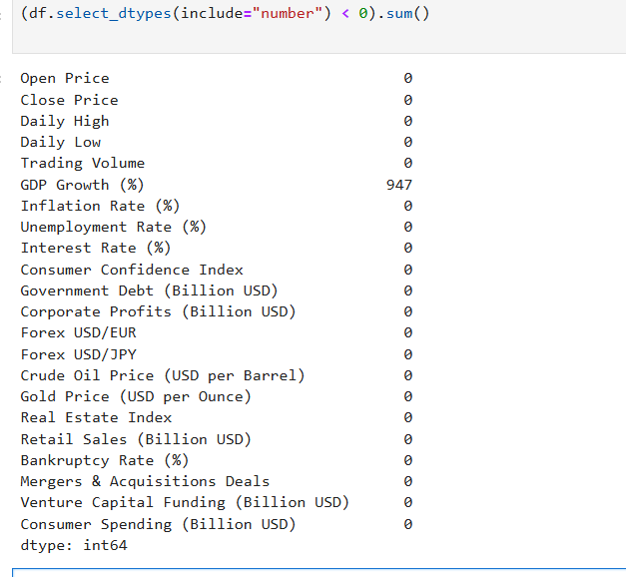
- What is the summary of GDP Growth (%)?
Ans:
df["GDP Growth (%)"].describe()

output:
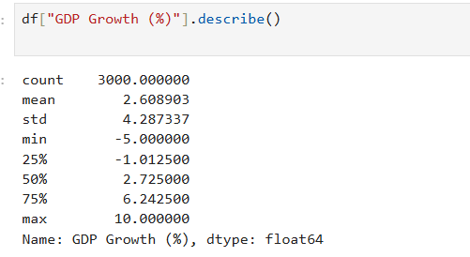
- Are there rows with zero or near-zero trading volume?
Ans:
(df["Trading Volume"] <= 10).sum()

Output:
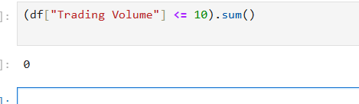
- Are there any duplicate rows?
Ans:
df.duplicated().sum()

output:
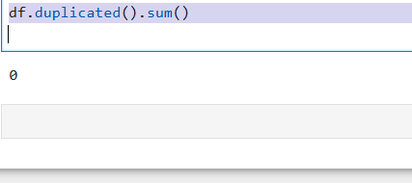
- Are there outliers in GDP, Gold, or Oil prices?
Ans:
import seaborn as sns
import matplotlib.pyplot as plt

sns.boxplot(
data=df[
[
"GDP Growth (%)",
"Crude Oil Price (USD per Barrel)",
"Gold Price (USD per Ounce)"
]
]
)

plt.title("Outlier Analysis: GDP Growth, Crude Oil, and Gold Prices")
plt.xticks(rotation=20)
plt.show()

output:
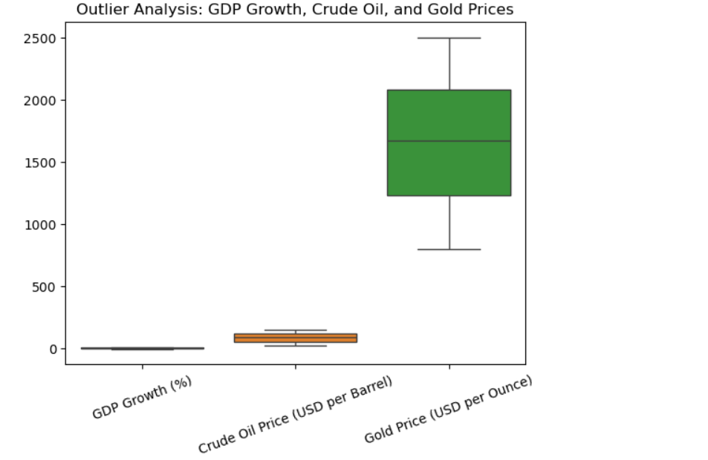
- What is the summary of Inflation Rate (%)?
Ans:
df["Inflation Rate (%)"].describe()

output:
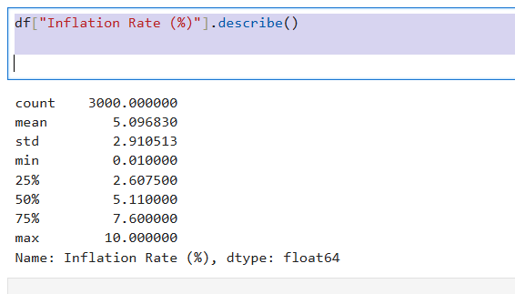
- What is the average unemployment rate?
Ans:
df["Unemployment Rate (%)"].mean()

output:
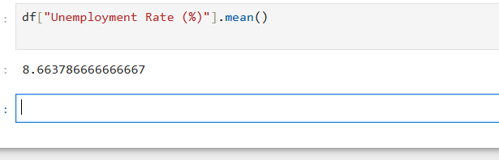
- Which index has the highest trading volume?
Ans:
df.groupby("Stock Index")["Trading Volume"].mean().idxmax()

output:
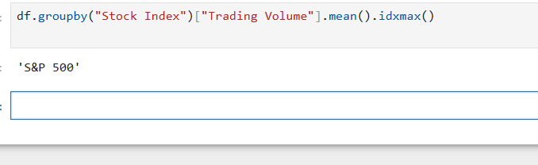
- How many stock records are from each index?
Ans:
df["Stock Index"].value_counts()

output:
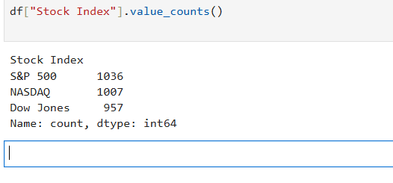

- What is the correlation between inflation and interest rate?
Ans:
df["Unemployment Rate (%)"].mean()

output:
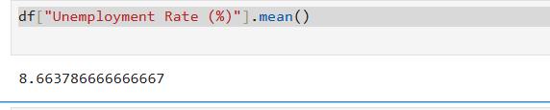

- What is the average Consumer Confidence Index?
Ans:
df["Consumer Confidence Index"].mean()

output:
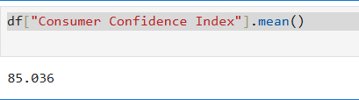

- Which column has the highest standard deviation?
Ans:

df.std(numeric_only=True).idxmax()

output:
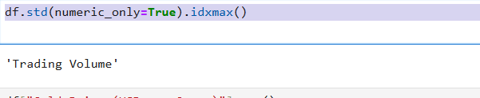

- What is the highest gold price recorded?
Ans:
df["Gold Price (USD per Ounce)"].max()

output:
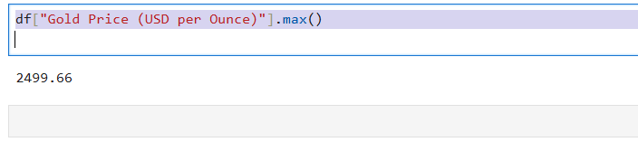

- Which date had the highest crude oil price?
Ans:
df.loc[df["Crude Oil Price (USD per Barrel)"].idxmax(), "Date"]

output:
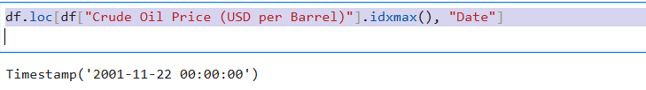

- What is the average corporate profit?
Ans:
df["Corporate Profits (Billion USD)"].mean()

output:
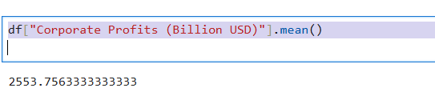

Insightful Analysis Questions These questions aim to uncover key relationships and gain deeper knowledge about cardiovascular disease. To answer them, you’ll need to analyze the data and write down any patterns, trends, or observations you notice during the process.

- What percentage of the dataset shows negative GDP growth?
Ans:
neg_gdp_pct = (df["GDP Growth (%)"] < 0).mean() * 100
neg_gdp_pct

output:

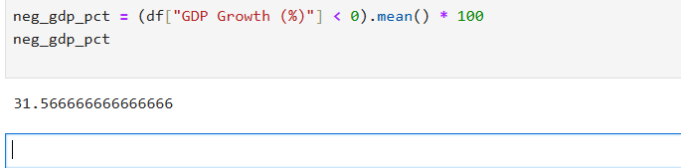

- Does high inflation correspond to higher interest rates?

Ans:
df["Inflation Rate (%)"].corr(df["Interest Rate (%)"])

output:

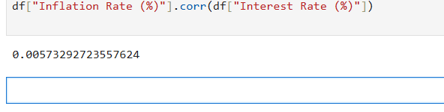

- Is there a relationship between unemployment and consumer spending?
Ans:
df["Unemployment Rate (%)"].corr(
df["Consumer Spending (Billion USD)"]
)

Output:
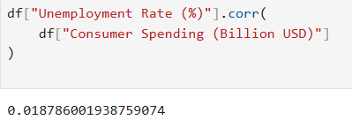

- Do higher corporate profits align with higher consumer confidence?
Ans:
profit_col = [c for c in df.columns if "Profit" in c][0]

df[profit_col].corr(df["Consumer Confidence Index"])

output:
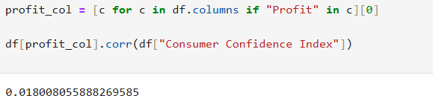

- What’s the trend of crude oil prices over time?
Ans:
plt.figure(figsize=(10,5))
plt.plot(df["Date"], df["Crude Oil Price (USD per Barrel)"])
plt.title("Crude Oil Price Trend Over Time")
plt.xlabel("Date")
plt.ylabel("Price")
plt.show()

output:
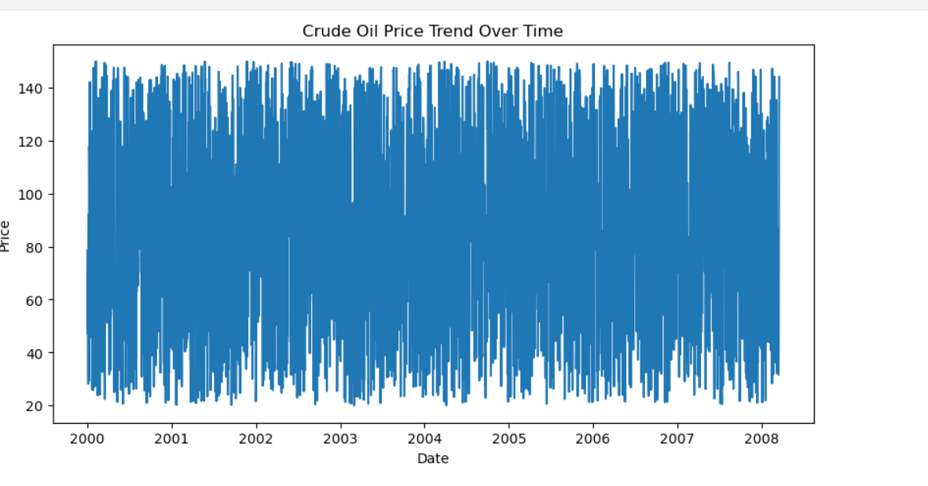

- Are gold prices inversely related to stock performance?
Ans:
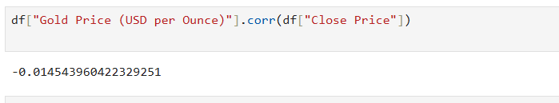

- Does government debt impact consumer confidence?
Ans:
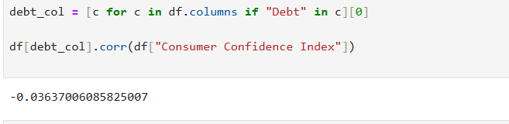

- How do mergers & acquisitions (M&A) activity correlate with stock index closing prices?
Ans:
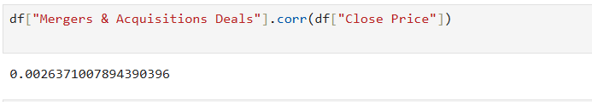

- Is retail sales growth associated with GDP growth?
Ans:
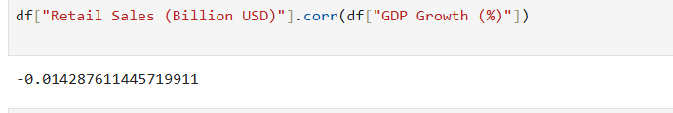
- Is stock market performance linked to consumer spending?
Ans:
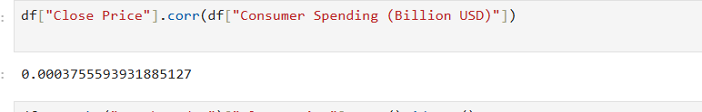

- Which stock index had the highest average closing price?
Ans:
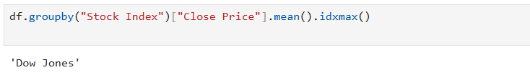

- What is the relationship between interest rate and unemployment?
Ans:
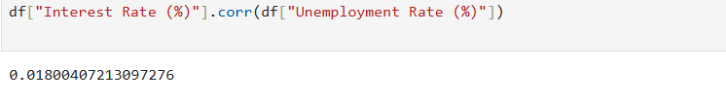

- Do lower consumer confidence values coincide with higher bankruptcy rates?
Ans:
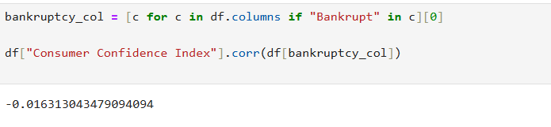

- Which indicator has the highest correlation with stock close price?
Ans:
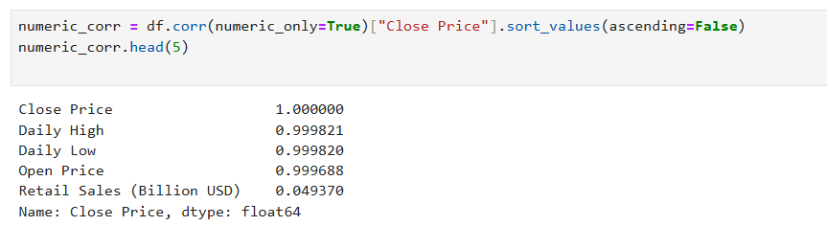

- Are unemployment rates lower when corporate profits are high?
Ans:
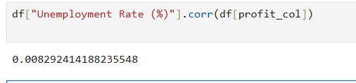

Assessment 2:
Retail Sales Analysis Dataset: https://github.com/Priya-tops/Tops-Assessment-Data/blob/main/Data%20Analytics/Retail %20Data.csv
Explore the Data by Answering the Following Questions and Summarize Your Insights Use Python libraries such as Pandas, NumPy, Matplotlib, and Seaborn to analyze the data. After answering each question, write a brief summary of your findings or observations.
- View the structure of the dataset (columns, types, missing values).

Ans:
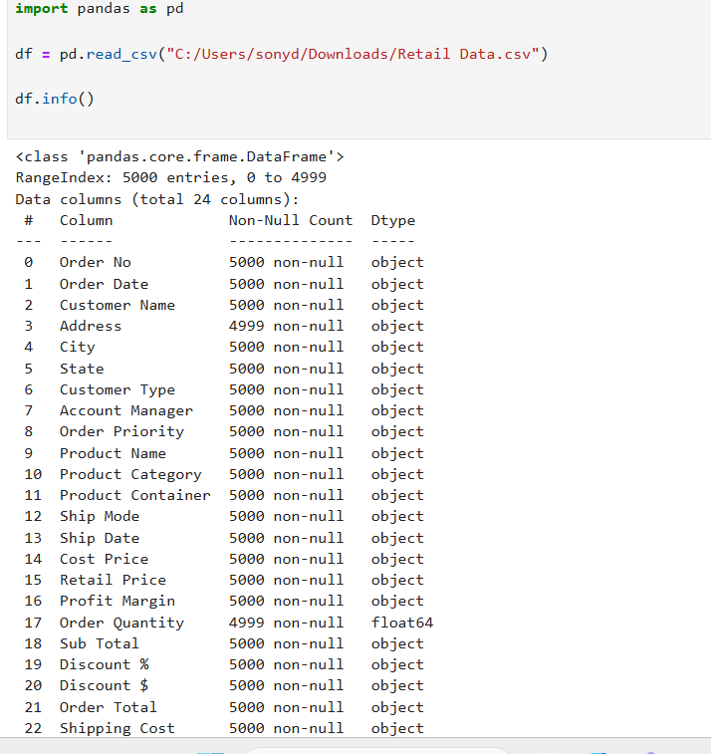

- What is the shape (rows, columns) of the dataset?
Ans:
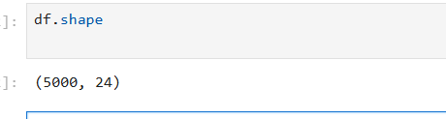

- Are there any duplicate records?
Ans:
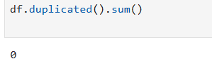

- Are there any missing or corrupted entries in Ship Date, Order Date, or numeric columns?
Ans:
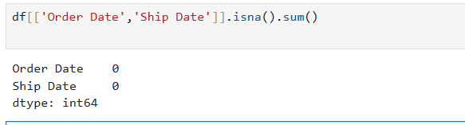

- Convert Order Date and Ship Date to datetime.
Ans:
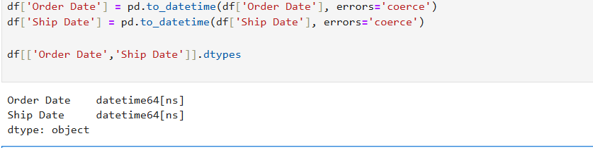

- Check for future or inconsistent shipping dates.
Ans:
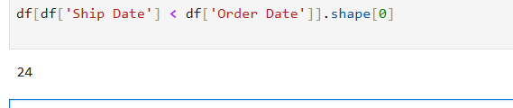

- Convert price columns to numeric (remove $ and commas).
Ans:
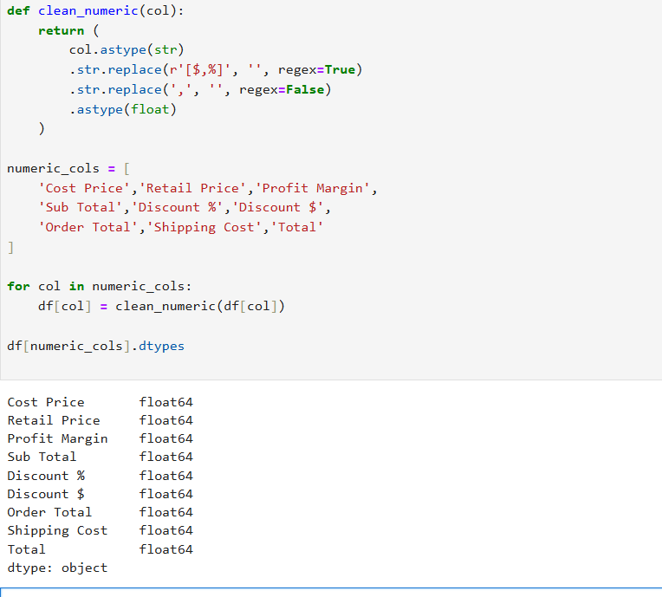

- What are the unique values in Customer Type and Order Priority?
Ans:
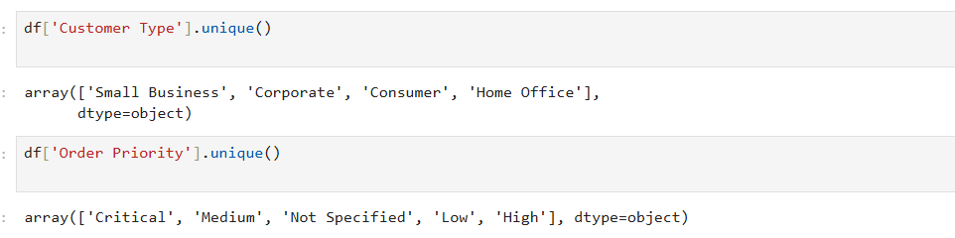

- What are the most common shipping modes?
Ans:
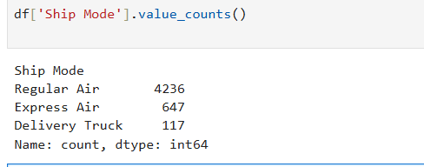

- Which cities have the highest number of orders?
Ans:
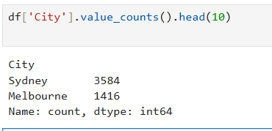

- What’s the range of order quantities and prices?
Ans:
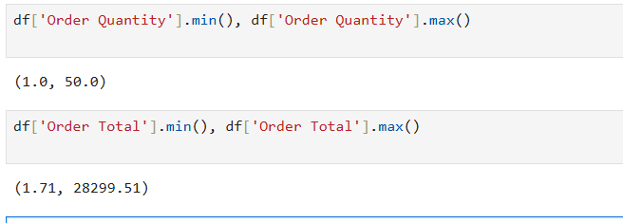

- Create a new column for shipping duration.
Ans:
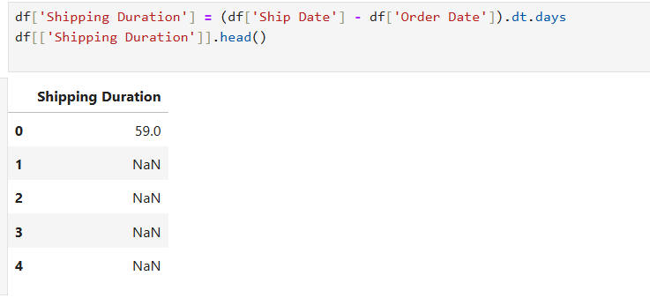

- Are there any orders with zero or negative total or quantity?
Ans:
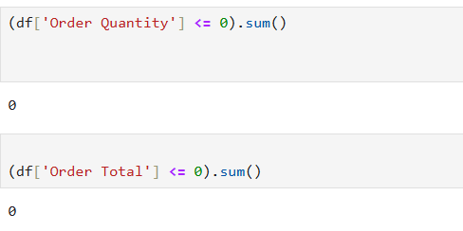

- Are all discount percentages matching discount dollar amounts?
Ans:
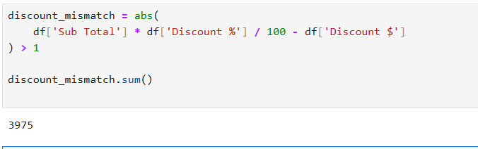

- Check for mismatches in total calculation.
Ans:
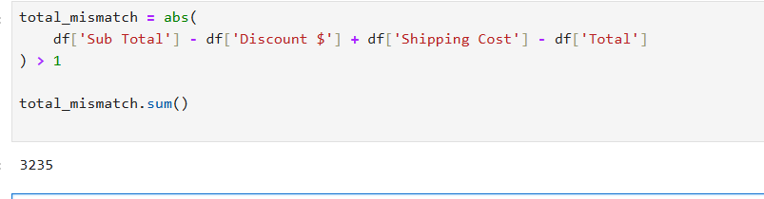

- Identify top 5 products by order quantity.
Ans:
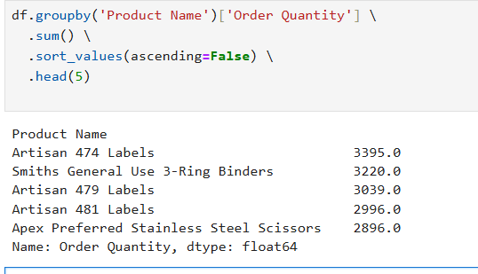

- Which Account Manager handled the most revenue?
Ans:
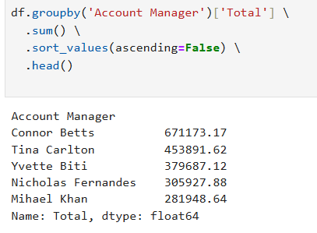

- What is the average shipping cost by mode?
Ans:
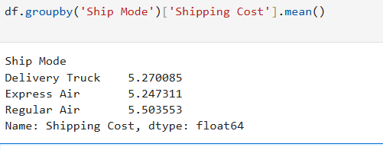

- Find the most profitable product.
Ans:
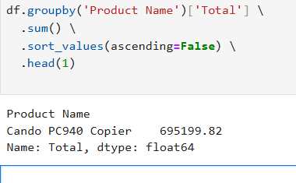

- Find the most profitable product.
Ans:
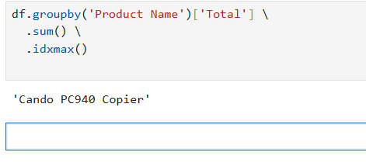

Insightful Analysis Questions
These questions aim to uncover key relationships and gain deeper knowledge about cardiovascular disease. To answer them, you’ll need to analyze the data and write down any patterns, trends, or observations you notice during the process.
- What is the total revenue generated across all orders?
Ans:
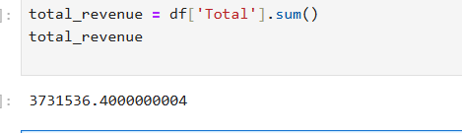

- Which customer type generates more revenue?
Ans:
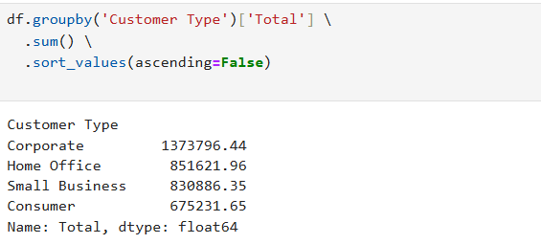

- How does order priority affect revenue?
Ans:
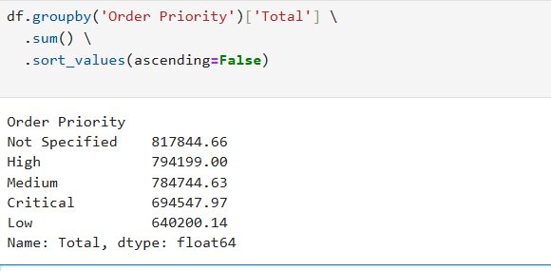

- What is the average profit margin by product category?
Ans:
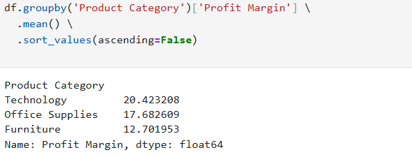

- What is the most profitable product overall?
Ans:
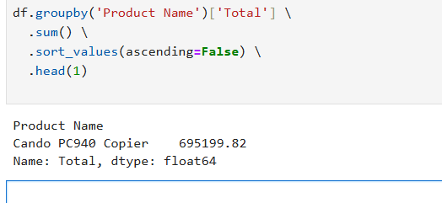

- How many days does it usually take to ship an order?
Ans:
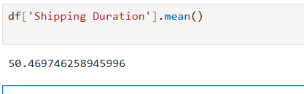

- Do longer shipping times impact profit margins?
Ans:
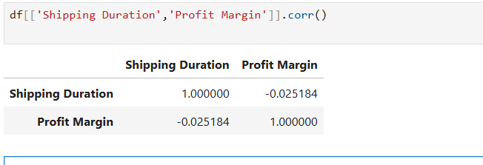

- Which city brings in the highest revenue?
Ans:
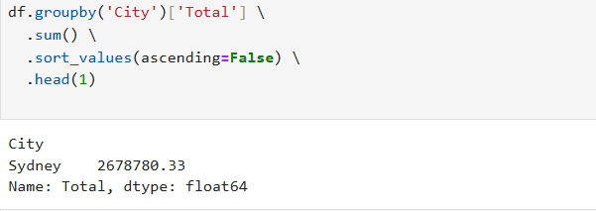

- Which account manager generated the most revenue?
Ans:
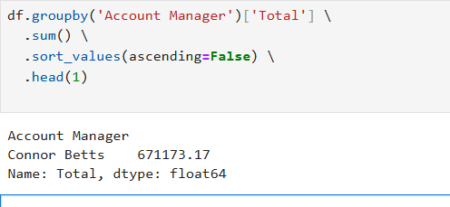

- Which shipping mode is most cost-effective (lowest avg. shipping)?
Ans:
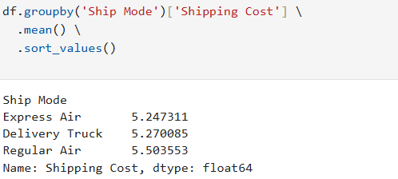

- Do higher discounts reduce profits?
Ans:
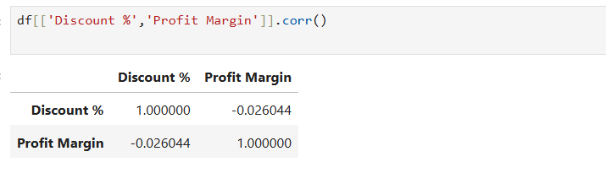

- Which state has the highest number of orders?
Ans:
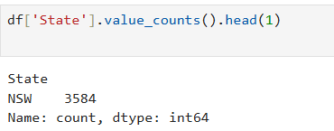

- What is the average discount % across all orders?
Ans:
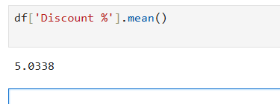

- What is the average total spend per order?
Ans:
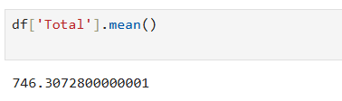

- . Are certain containers (e.g., Small Box, Wrap Bag) more profitable?
Ans:
